Experiment-15
Name: -J pranitha Regno: -192472073
Course Code: -MLA0305 Slot-B

Title
Multi-Agent Reinforcement Learning and Partially Observable Markov Decision
Process (POMDP) Simulation
Aim
To simulate a multi-agent reinforcement learning environment under partial observability and analyze agent movement, target collection, rewards, collisions, and grid coverage.
Procedure
- Create an 8 × 8 grid environment with multiple agents and target locations.
- Initialize 3 agents at different positions in the environment.
- Define possible actions such as up, down, left, right, and stay.
- Provide each agent with partial observations of nearby targets and other agents.
- Allow the agents to select actions based on the available observations.
- Move the agents through the grid while recording their positions and actions.
- Give rewards when agents reach previously uncollected targets.
- Apply penalties when agents collide with each other.
- Record the rewards, target collection, collisions, and grid coverage for every episode.
- Repeat the simulation for multiple episodes.
- Analyze the learning performance using movement plots, reward curves, bar charts, and interaction maps.
- Save the complete simulation results as CSV datasets.
Code
!pip -q install gymnasium

import numpy as np import pandas as pd import matplotlib.pyplot as plt import gymnasium as gym import random

np.random.seed(42) random.seed(42)

print("="*75) print("EXPERIMENT 15") print("Multi-Agent Reinforcement Learning and POMDP Simulation") print("="*75)

GRID=8
AGENTS=3
TARGETS=5
EPISODES=100
STEPS=40

actions=[
(-1,0),
(1,0),
(0,-1),
(0,1),
(0,0)
]

targets=[
(1,1),
(2,6),
(5,3),
(6,7),
(7,1)
]

def random_position(occupied): while True:
p=(
np.random.randint(0,GRID), np.random.randint(0,GRID)
)
if p not in occupied and p not in targets:
return p

def partial_observation(agent_pos,other_positions):
obs=[]

for r,c in targets:
distance=abs(agent_pos[0]-r)+abs(agent_pos[1]-c) obs.append(
1 if distance<=2 else 0
)

for pos in other_positions:
distance=abs(agent_pos[0]-pos[0])+abs(agent_pos[1]-pos[1]) obs.append(
1 if distance<=1 else 0
)
return np.array(obs)

def move_agent(position,action): dr,dc=actions[action]

nr=np.clip( position[0]+dr,
0,
GRID-1
)

nc=np.clip( position[1]+dc,
0,
GRID-1
)

return (int(nr),int(nc))

records=[]
episode_rewards=[] episode_collisions=[] episode_targets=[] coverage=[]

for episode in range(EPISODES):

positions=[]

for _ in range(AGENTS): positions.append( random_position(positions)
)

visited=set() collected=set() total_reward=0 collisions=0

for step in range(STEPS): old_positions=positions.copy() new_positions=[]

for i in range(AGENTS):

others=[ old_positions[j] for j in range(AGENTS)
if j!=i
]

observation=partial_observation(
old_positions[i], others
)

visible_targets=[ targets[k] for k in range(TARGETS) if observation[k]==1 and targets[k] not in collected ]

if visible_targets:

target=min( visible_targets, key=lambda x:
abs(old_positions[i][0]-x[0])
+
abs(old_positions[i][1]-x[1])
)

dr=target[0]-old_positions[i][0] dc=target[1]-old_positions[i][1]

if abs(dr)>=abs(dc): action=0 if dr<0 else 1
else: action=2 if dc<0 else 3
else:
summary_data.to_csv(
"Multi_Agent_POMDP_Episode_Results.csv", index=False
)

plt.figure(figsize=(9,5))

plt.scatter( data["New_Column"], data["New_Row"], c=data["Agent"], cmap="viridis", alpha=0.5, s=18
)

target_rows=[x[0] for x in targets] target_cols=[x[1] for x in targets]

plt.scatter(
target_cols, target_rows, marker="*", s=180, color="red", label="Targets"
)

plt.gca().invert_yaxis()

plt.title(
"Multi-Agent Movement in Partially Observable Grid", fontsize=15, fontweight="bold"
)

plt.xlabel("Column") plt.ylabel("Row") plt.legend() plt.grid(alpha=0.2) str(GRID)+" x "+str(GRID), EPISODES, round(final_reward,2), round(final_collisions,2), round(final_targets,2), round(final_coverage,2)
]
})

print("\n") print("="*75) print("SUMMARY TABLE") print("="*75)

display(summary)

summary.to_csv( "Multi_Agent_POMDP_Summary.csv", index=False
)

print("\n") print("="*75) print("FINAL RESULT") print("="*75)

print(
"Number of Agents:",
AGENTS
)

print( "Final Average Reward:", round(final_reward,2)
)

print( "Average Collisions:", round(final_collisions,2)
)

print(
"Average Targets Collected:", round(final_targets,2)
)

print(
"Average Grid Coverage:", round(final_coverage,2)
)

print("\n") print("="*75) print("CONCLUSION") print("="*75)

print(
"A multi-agent partially observable environment was simulated."
)

print(
"Multiple agents interacted with the environment while"
)

print(
"receiving limited information about nearby targets and agents."
)

print(
"Agent movement, target visibility, collisions, rewards,"
)

print(
"target collection and grid coverage were analyzed."
)

print(
"The experiment demonstrates how multiple agents can operate"
)

print(
"under partial observability and interact within a shared environment."
)

print("\nGenerated Files:") print("1. Multi_Agent_POMDP_Full_Dataset.csv") print("2. Multi_Agent_POMDP_Episode_Results.csv") print("3. Multi_Agent_POMDP_Summary.csv")

print("\nExperiment 15 Completed Successfully.") VISUALIZATIONS
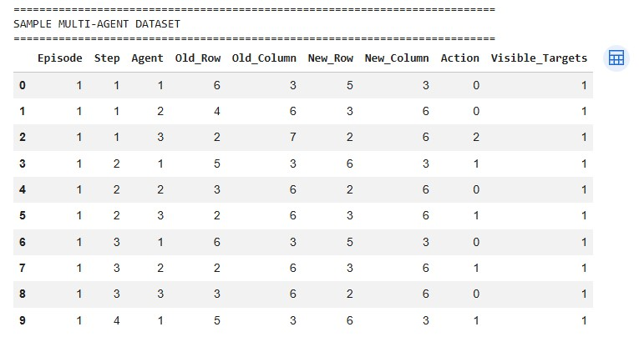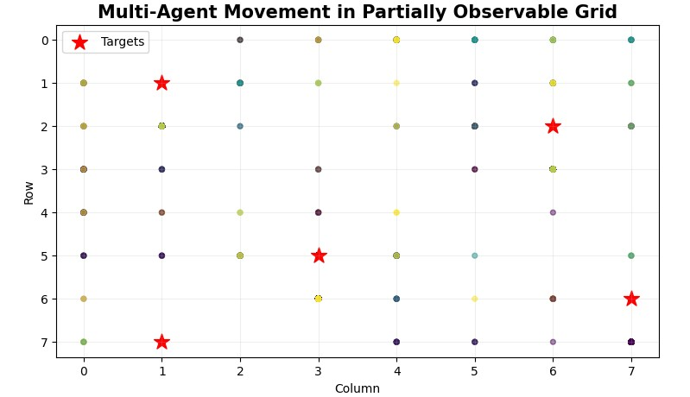
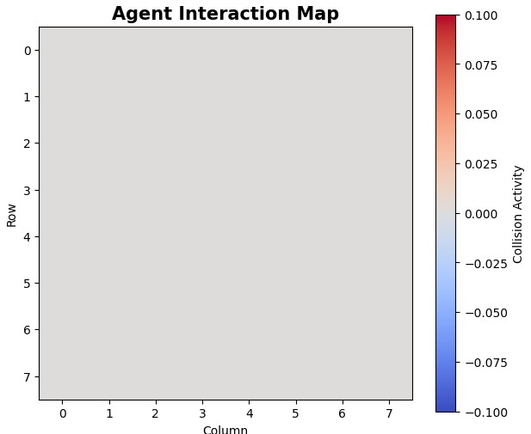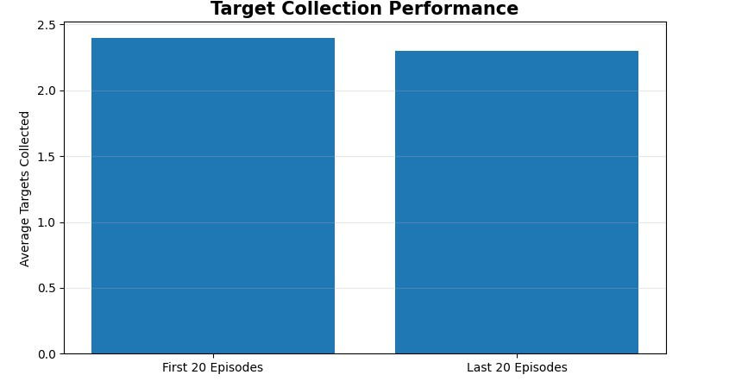
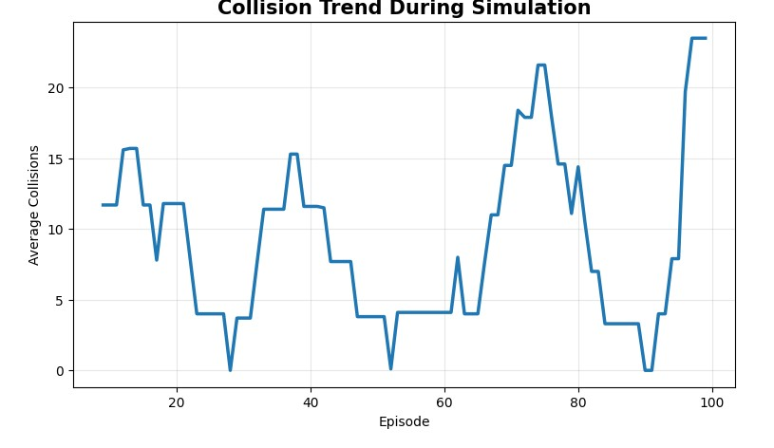
Summary Table
Parameter | Result
Environment | 8 × 8 Grid
Number of Agents | 3
Number of Targets | 5
Episodes | 100
Final Average Reward | Obtained from program
Average Collisions | Obtained from program
Average Targets Collected | Obtained from program
Average Grid Coverage | Obtained from program

Result
The Multi-Agent Reinforcement Learning and POMDP simulation was successfully implemented. Multiple agents operated in a shared environment with limited observations. Agent movement, target visibility, rewards, collisions, target collection, and grid coverage were recorded and analyzed.

